D I G I T A L H E A L T H • P Y T H O N P R O J E C T

Patient Medication Reminder and Adherence Log
Scheduling dose reminders, logging adherence, and reporting progress to the doctor — built end-to- end in Python.

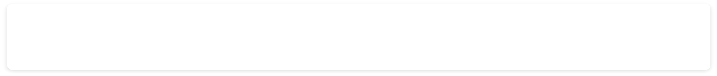
Problem Statement
Patients on multi-dose prescriptions often forget doses or lose track of what they’ve already taken. Doctors, in turn, have no easy
record of how well a patient is following their prescribed schedule between visits.
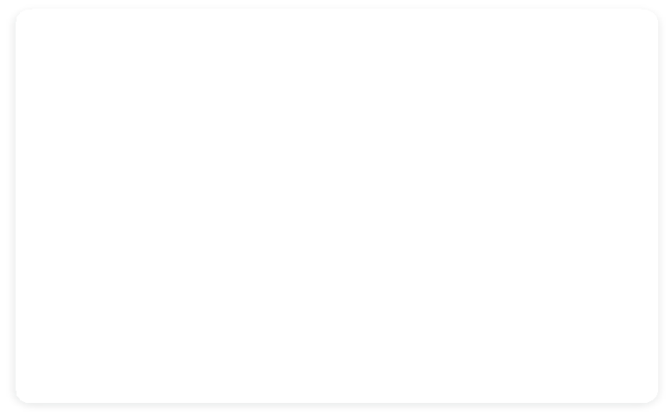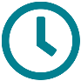
Missed Doses
No automatic reminders mean doses are easy
to forget, especially on multi-times-a-day schedules.
No Adherence Record
Taken / missed doses aren’t logged anywhere
the patient or doctor can review later.
Blind Doctor Visits
Doctors must rely on the patient’s memory
instead of real data when reviewing treatment.

Patient Medication Reminder & Adherence Log 2

Project Objectives

What the application sets out to do

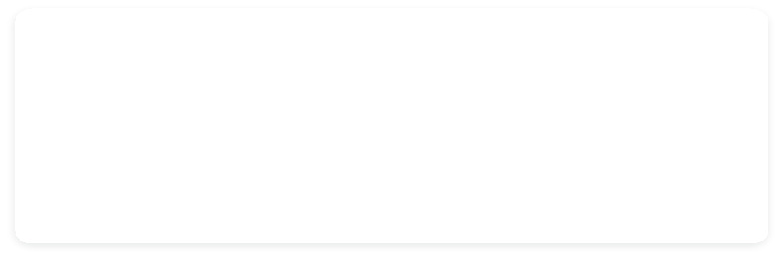
Build a prescription schedule engine
Convert a doctor’s prescription into a precise set of daily
reminder times.
Deliver timely dose reminders
Notify the patient at the right moment for every
scheduled dose, every day.
Log every dose as taken or missed
Give the patient a one-tap way to record what actually
happened.
Generate a weekly adherence report
Summarize adherence trends into a clear report the
doctor can review.
Stay correct across time zones
Keep reminder times accurate even when the patient’s
phone changes time zone.
Support varied dosing intervals
Handle both fixed clock-time schedules and rolling every-
N-hour schedules.

Patient Medication Reminder & Adherence Log 3

Core Use Cases

Two capabilities drive the entire system design

U s e C a s e 1

Schedule Dose Reminders & Log Adherence
Parse a prescription (drug, dose, frequency, duration) into a reminder schedule. At each scheduled time, notify the patient and
record their response as Taken or Missed in a persistent log.

U s e C a s e 2

Generate a Weekly Adherence Report
Aggregate a week of taken/missed logs per medicine into adherence percentages and trends, then export a clear summary the
patient can share with their doctor.

Patient Medication Reminder & Adherence Log 4

System Architecture

How data flows from prescription to doctor’s report

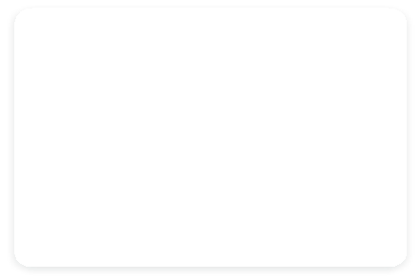
Prescription Input
Scheduler Engine
Reminder Service
Adherence Log
Weekly Report
Drug, dose,
frequency, duration
Builds dose times
(clock-based / interval)
Fires notifications
at due times
Stores taken / missed
events with timestamps
Summarized for
the doctor

Built as three Python layers

- Data layer — SQLite (via sqlite3) storing prescriptions, schedules and dose logs

- Logic layer — schedule generation, timer/reminder checks, report aggregation

- Interface layer — CLI or Tkinter GUI for reminders, logging taps, and reports

Patient Medication Reminder & Adherence Log 5


Technology Stack
Core Language
Python 3
Scheduling logic, CLI/app control flow, report generation

Data Storage
SQLite (sqlite3 module)
Lightweight local database for prescriptions and dose logs
Scheduling
datetime, schedule / APScheduler
Computing dose times and triggering reminders
Interface
Tkinter (GUI) or CLI menu
Patient-facing reminder pop-ups and adherence entry
Reporting
pandas + matplotlib (optional)
Weekly adherence percentages and simple trend charts

Patient Medication Reminder & Adherence Log 6

Database Design
Three simple tables cover the whole workflow

Prescriptions
ScheduleSlots
DoseLogs

prescription_id PK
slot_id PK
log_id PK

patient_id
prescription_id FK
slot_id FK

medicine_name
1 : N
scheduled_time (local)
1 : N
status: taken / missed

dose
scheduled_time (UTC)
logged_at (timestamp)

frequency_type
timezone_at_creation
notes (optional)

interval_hours
start_date / end_date

Patient Medication Reminder & Adherence Log 7

Scheduling Logic
Two different clock strategies, one schedule table

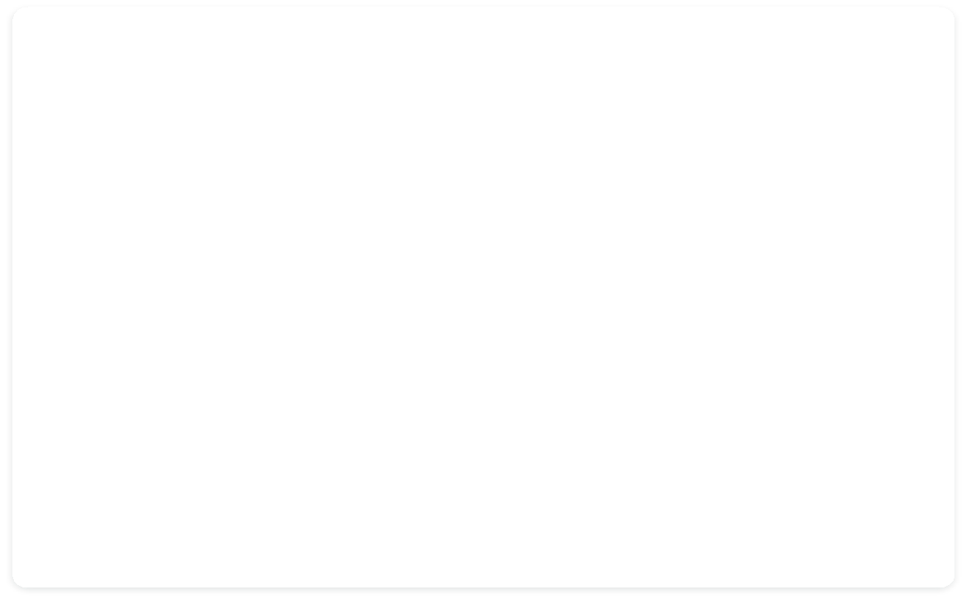Fixed Clock-Time Schedule

"Twice daily", "3 times a day" → anchored to fixed times of day, independent
of when the first dose was taken.

Rolling Interval Schedule

"Every 8 hours" → anchored to the actual time of the previous dose, not the
wall clock.

08:00 20:00
06:10 14:10 22:10

same wall-clock time, every day

Rule: reset to the next fixed slot each day, even if a dose was taken late.

+8h chained from actual dose time

Rule: recompute the next slot as (last taken time + interval), so a late dose shifts
the whole day’s chain.

Patient Medication Reminder & Adherence Log 8

BOTTLENECK 01
Different Clock Logic for Different Schedules


T H E P R O B L E M

A naive scheduler that just adds a fixed interval breaks one of the two
common prescription styles:
Twice-daily plans need fixed anchor times (e.g. 8 AM / 8 PM) that stay put
regardless of when a dose is actually taken.
Every-8-hour plans need a rolling chain from the last actual dose time —
using fixed anchors here drifts the schedule.
Using one clock rule for both cases causes reminders to fire at the wrong
time or bunch together.
T H E S O L U T I O N

Model each prescription with a frequency_type flag and branch the
schedule generator accordingly:
if freq_type == 'FIXED_TIMES': slots = anchor_times_today()
elif freq_type == 'INTERVAL':
nxt = last_dose_time + interval slots = [nxt]
FIXED_TIMES: precompute a static daily list of times, regenerated at
midnight.
INTERVAL: recompute the next single slot right after each dose is logged.

Patient Medication Reminder & Adherence Log 9

BOTTLENECK 02
Time-Zone Changes Shift Reminders

T H E P R O B L E M
If reminder times are stored only in local time, travel or a system time-zone
change silently shifts every future dose:
Patient in Delhi (UTC+5:30) sets 9:00 PM dose → flies to New York (UTC-
4).
A naive app keeps firing at "9:00 PM device time" — now 9.5 hours off
from the intended dosing gap.
Result: doses logged too close together, or dangerously spaced apart, without the
patient noticing.
T H E S O L U T I O N

Anchor every schedule slot to an absolute instant, not a local clock string:
Store each slot in UTC (datetime, timezone.utc); convert to local time only
for display.
On app start / resume, detect the device’s current time zone and re-render
(not recompute) reminder times.
For INTERVAL schedules, keep counting from the UTC timestamp of the last
dose — the interval logic never changes.
Use a library such as pytz / zoneinfo to handle conversions and daylight-
saving edge cases.

Patient Medication Reminder & Adherence Log 10

Weekly Adherence Report

Turning raw dose logs into something a doctor can act on
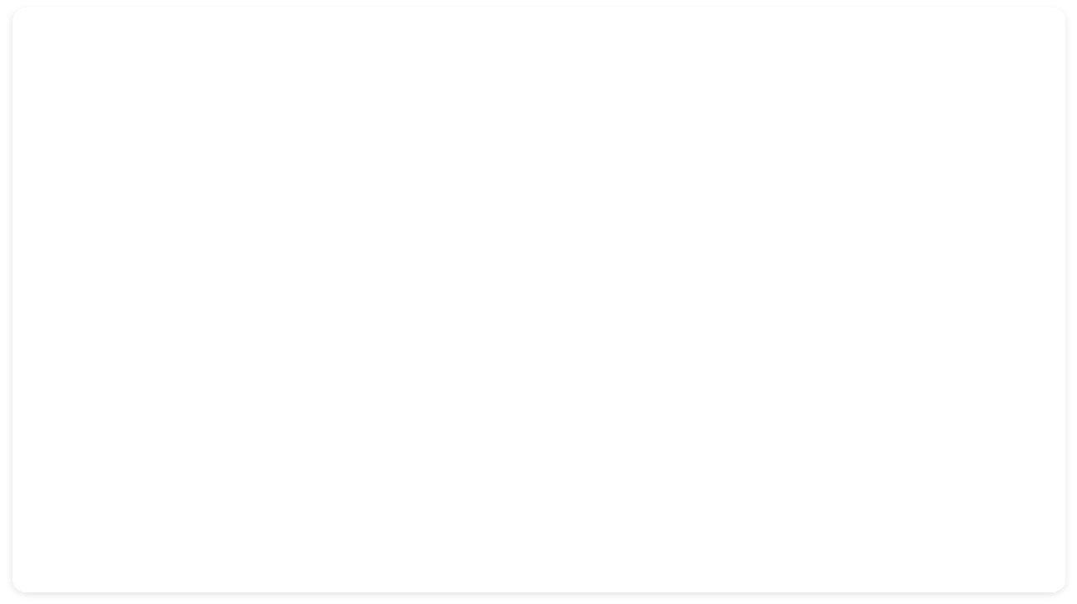
Adherence by Day — Sample Week
100
100
100
100
100
100
90

80

70

60
50
50
50

40

30

20

10

0
Mon
Tue
Wed
Thu
Fri
Sat
Sun
Report Contents
Per-medicine adherence %
doses taken ÷ doses scheduled, for each prescription

Missed-dose timeline
exact times doses were skipped during the week

Overall weekly score
single headline % across all medicines Trend vs. previous week improving, steady, or declining adherence Doctor-ready export
PDF / text summary attached to the patient record

Patient Medication Reminder & Adherence Log 11

Module Breakdown

Suggested Python file / module structure

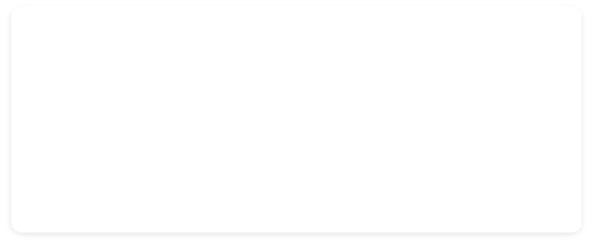

prescriptions.py

Add / edit prescriptions; validates dose, frequency & duration input.

scheduler.py

Generates dose slots for FIXED_TIMES and INTERVAL schedules; handles time-zone conversion.

reminders.py

Polls upcoming slots and triggers notifications (CLI print / GUI pop-up / OS notification).

storage.py

SQLite connection layer — CRUD for prescriptions, schedule slots and dose logs.

reports.py

Aggregates a week of logs into per-medicine and overall adherence statistics.

app.py / main.py

Entry point tying modules together; CLI menu or Tkinter GUI event loop.

Patient Medication Reminder & Adherence Log 12

Future Scope

Where this project could grow beyond the mini-project scope


Native mobile push notifications
Move from desktop pop-ups to real
Android/iOS push alerts.
Doctor-side web dashboard
Let doctors log in and view multiple
patients’ adherence remotely.
Predictive risk flags
Use adherence history to flag patients at
risk of non-compliance.
Multi-caregiver alerts
Notify a family member if a critical dose is
missed.

Patient Medication Reminder & Adherence Log 13

Thank You

A small Python project with real everyday impact — helping patients stay on schedule
and giving doctors the data to actually see it.
14

Patient Medication Reminder & Adherence Log

